Download PAC-MCU ATMEGA8
*Denver MP3 program은 Septa MP3 program과 혼환된단.
1. Connect Device

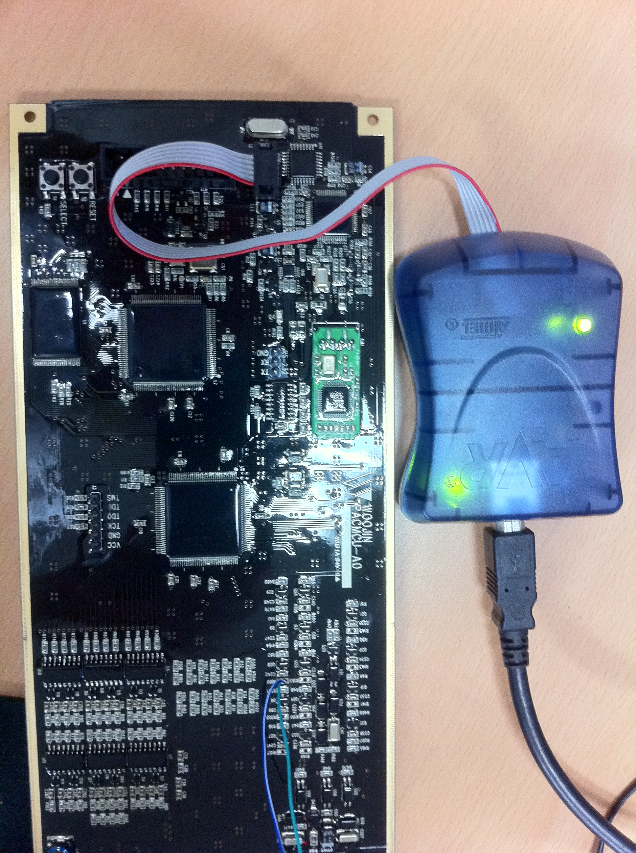

2. Run AVRStudio.exe Program

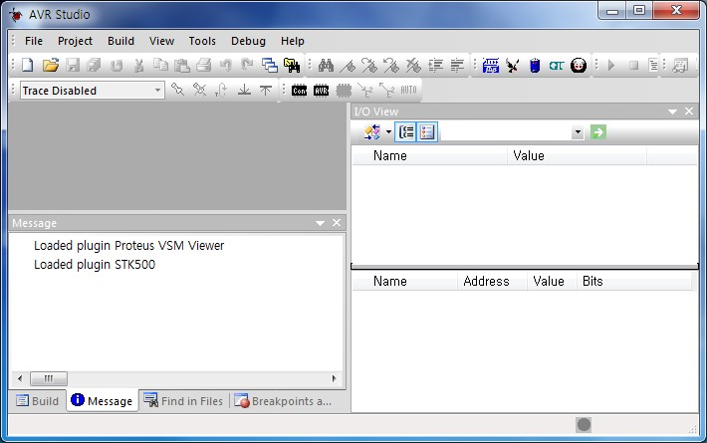
3. Click button

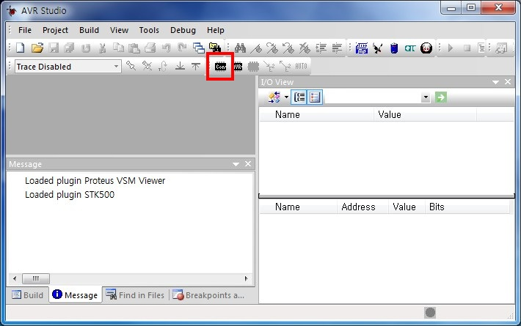

4. Check AVRISP mkII and USB – Click Connect button

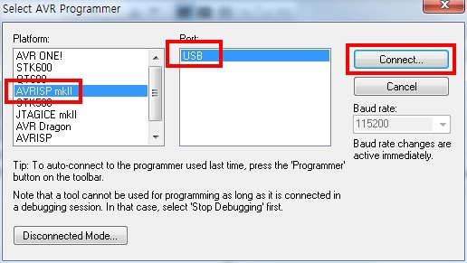

5. Check ATmega8 – Click Fuses Menu

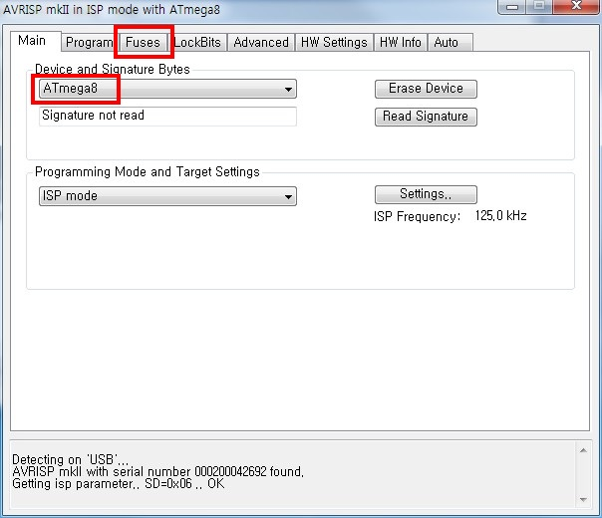

6. Check SPIEN and SUT_CKSEL – Click Program Menu

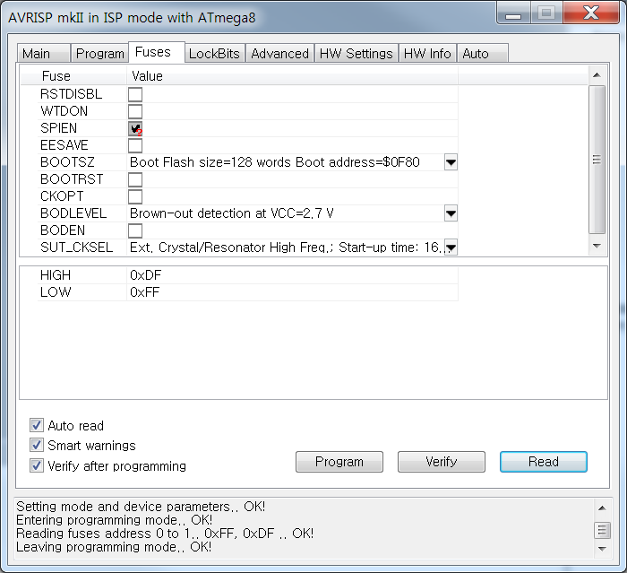
7. Click button

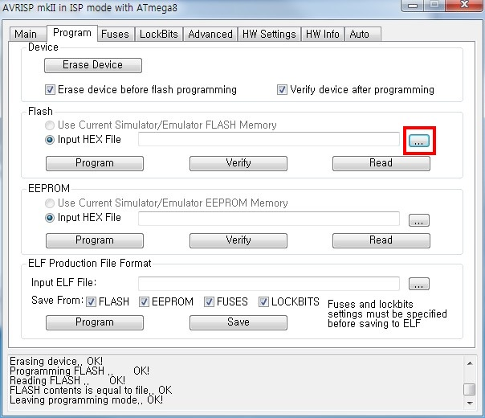

8. Choose Septa_MP3_150706.hex – Click Open button

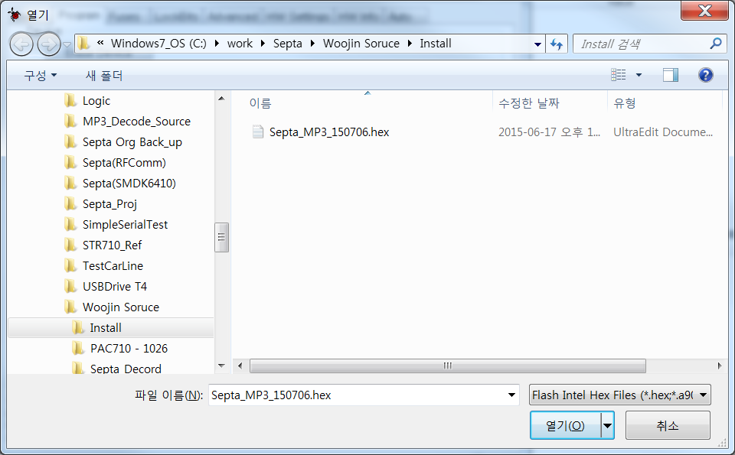

9. Check Septa_MP3_150706.hex – Click Program button

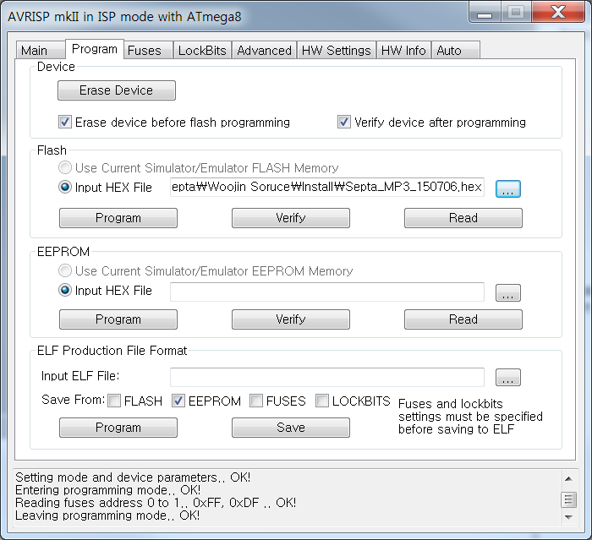

10. Check OK – Download Complete

